**Create 1folder and 2 files:**

Folder name: my_folder

File name1: my_file.txt

File name2: another_file.txt

Concatenate 2 files to another file(concatenate.txt)

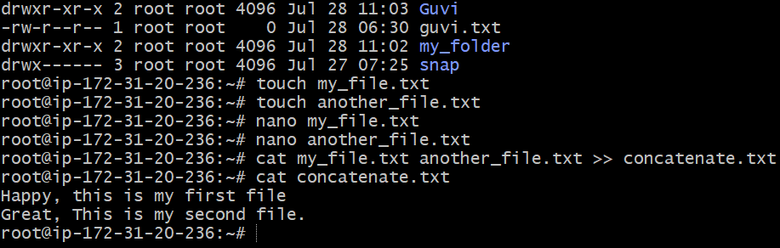

**Creating 20 txt files:**

File name: File1 to File20

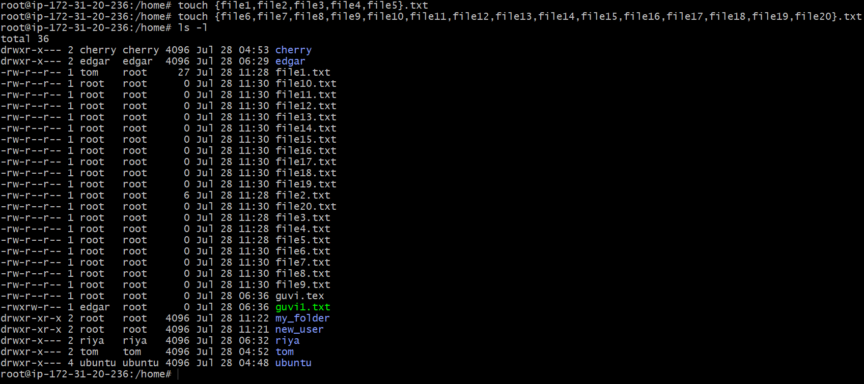

**Inserting same text to multiple files:**

Vim keyword used to insert information in many TXT files

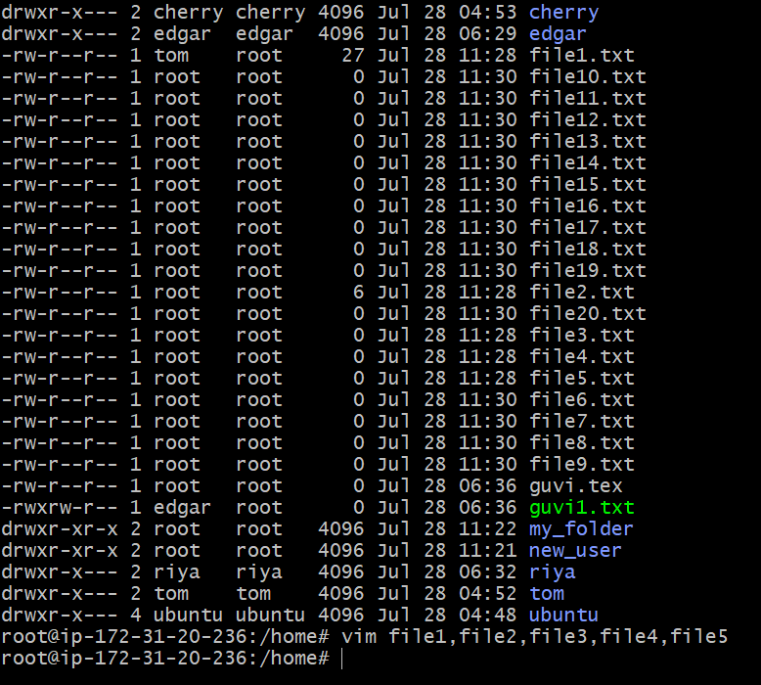

**To print files:**

